**Elevating Recycling Equipment Durability with Abrasion Resistant Steel**

Recycling processes demand robust equipment that can withstand the rigors of sorting, processing, and handling various materials. Abrasion Resistant Steel emerges as a transformative solution, enhancing the durability and longevity of key recycling equipment across diverse applications.

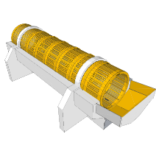**A. Screening Drums: Enhancing Efficiency and Wear Resistance**

Screening drums, also referred to as rotary drums or trommel screens, play a pivotal role in the recycling process. These drums offer versatile functionality by efficiently sorting, classifying, and size-splitting waste and bulk materials. From segregating recyclables to categorizing materials for further processing, screening drums streamline operations. However, this efficiency comes at a cost — the wear and tear inflicted by abrasive materials like glass, metals, and gravel. This is where Abrasion Resistant Steel proves its mettle. Designed to withstand severe wear, this steel's exceptional toughness becomes the shield against the relentless impact of abrasives, minimizing wear-induced downtime and maximizing equipment productivity.

**Grades:** AR400 or AR450 steel is a good choice for screening drums. These steel grades are hard enough to resist wear from the materials being screened, but they are also ductile enough to be formed and machined.

**B. Shear Shredders: Cutting Edge Durability and Performance**

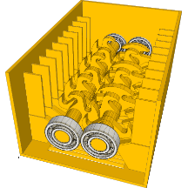

In the realm of recycling, shear shredders hold the responsibility of processing tough and dense materials like baled scrap metal. The heart of a shear shredder lies in its sharp knives, essential for effective cutting and processing. Here, the concept of unmatched durability gains significance. When subjected to extreme conditions and the challenge of cutting through formidable materials, Abrasion Resistant Steel emerges as the knight in shining armour. With its remarkable combination of extreme hardness and unmatched toughness, this steel variety significantly extends the lifespan of shear shredders, allowing them to endure the demanding conditions inherent in the recycling process.

**Grade:** AR500 or AR600 steel is a good choice for shear shredders. These steel grades are very hard and resistant to wear, making them ideal for applications where the material being shredded is very abrasive.

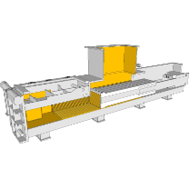**C. Scrap Balers: Efficient Compaction and Wear Resistance**

The concept of efficient waste compaction takes centre stage with scrap baler presses. These machines are tasked with compacting stamping press waste, often consisting of materials like steel, brass, copper, and aluminium plate. The compaction process subjects the equipment to intense forces and pressures, which can lead to accelerated wear and tear. In such scenarios, the role of wear resistance becomes paramount. Enter Abrasion Resistant Steel, a solution that empowers scrap balers to combat the wear and tear resulting from the rigorous compacting action. By withstanding these forces, this steel variant ensures the longevity and sustained performance of scrap baler presses, contributing to streamlined waste management operations.

**Grade:** AR400 or AR450 steel is a good choice for scrap balers. These steel grades are hard enough to resist wear from the materials being baled, but they are also ductile enough to be formed and machined.

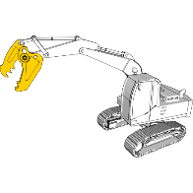**D. Demolition Attachments: Versatility Reinforced for Prolonged Use**

Demolition jaw attachments, encompassing an array of functionalities such as concrete cracking, scrap shearing, and wire cutting, are indispensable tools in recycling, scrap processing, and cable recycling applications. These attachments offer versatility, allowing for swift adaptation to different tasks. However, the wear and tear inflicted during these processes can significantly impact the equipment's lifespan. The concept of prolonged service life takes shape here. Water jet-cut jaws crafted from Abrasion Resistant Steel showcase exceptional wear resistance properties, thereby substantially extending their operational life. This not only reduces equipment replacement costs but also enhances the efficiency and productivity of demolition and recycling endeavours.

**Grade:** AR400 or AR450 steel is a good choice for demolition attachments. These steel grades are hard enough to resist wear from the materials being demolished, but they are also ductile enough to be formed and machined.

E. **Wood Chippers: Streamlined Processing with Extended Longevity**

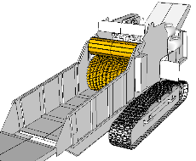

Efficiency in wood processing is the hallmark of wood chippers, which transform bulky tree limbs and trunks into manageable wood chips. However, this efficiency can be compromised by the presence of contaminants like gravel, leading to accelerated wear and tear within the chipper components. The idea of wear reduction success becomes vital. Abrasion Resistant Steel emerges as a reliable ally, mitigating wear across various wood chipper components. By providing enhanced protection against abrasive elements, this steel variety ensures that wood chippers operate with sustained longevity, contributing to seamless wood waste management processes.

**Grade:** AR400 or AR450 steel is a good choice for wood chippers. These steel grades are hard enough to resist wear from the wood being chipped, but they are also ductile enough to be formed and machined.